Project Design Phase
Solution Architecture

Date | 15 February 2025
Team ID | SWTID-2026-6064
Project Name | Streamlining IT Procurement: Automating Standard Laptop Orders with Flow Designer
Maximum Marks | 4 Marks

Solution Architecture:
Solution architecture is a complex process – with many sub-processes – that bridges the gap between business problems and technology solutions. Its goals are to:
- Find the best tech solution to solve existing business problems.
- Describe the structure, characteristics, behavior, and other aspects of the software to project stakeholders.
- Define features, development phases, and solution requirements.
- Provide specifications according to which the solution is defined, managed, and delivered.
Solution Architecture Diagram:
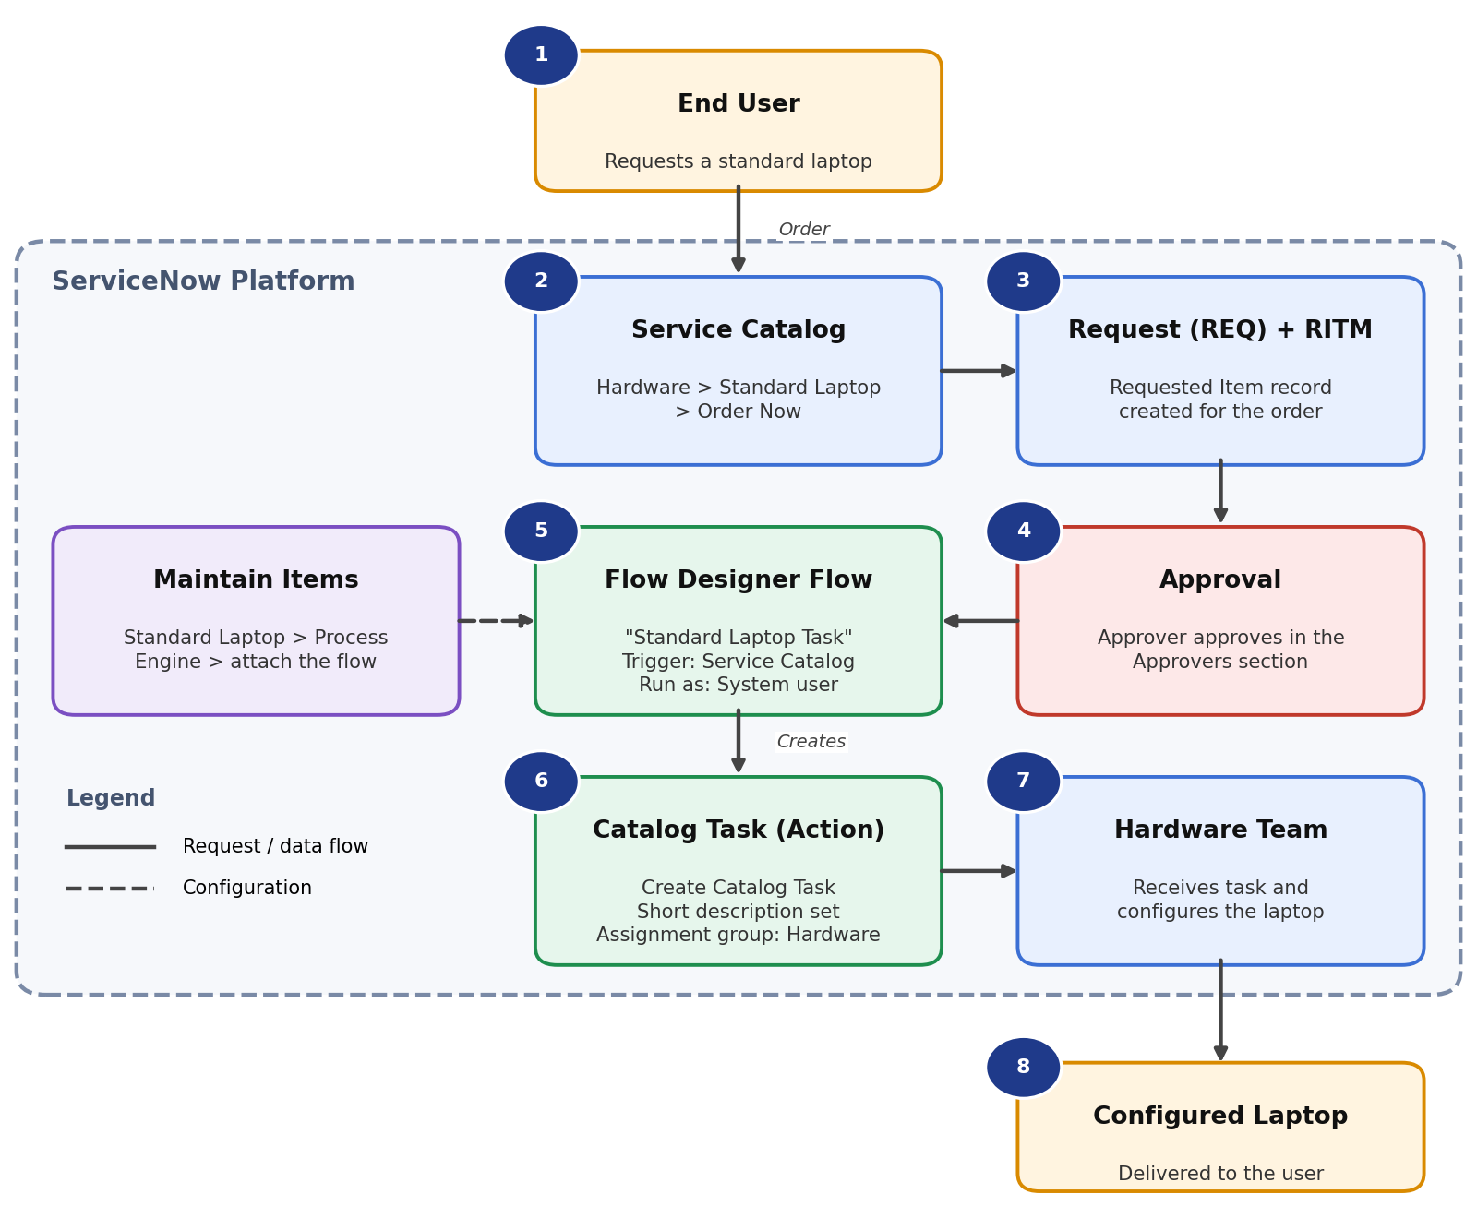
Figure 1: Architecture and data flow of the Standard Laptop order automation

Components and Data Flow:
- End User – places the request for a standard laptop through the Service Catalog (Hardware > Standard Laptop > Order Now).
- Service Catalog – the Standard Laptop catalog item captures the order and shows the order status with the request number.
- Request (REQ) and Requested Item (RITM) – records created automatically for the order; they carry the approval and the catalog tasks.
- Approval – the approver approves the request from the Approvers section of the request record.
- Flow Designer flow “Standard Laptop Task” – triggered by the Service Catalog trigger (Application: Global, Run as: System user). The flow is attached to the catalog item through Maintain Items > Process Engine.
- Catalog Task – the Create Catalog Task action links the task to the Requested Item and sets the short description, description and Assignment group (Hardware).
- Hardware Team – receives the configuration task and configures the laptop on arrival.
- Configured Laptop – delivered to the user, reducing wait time and manual follow-up.

